# **Food Ratings in Montreal**

Jessica Dash

23rd Jan, 2021

**Introduction**

In Montreal City, there are a number of places to grab a bite to eat, with a lot of variation over a large area. Some people just want to grab and go and do not care about where they eat, but for those people who want to look at their nearby options and compare, this study is going to help people in their decision on where to go. Using Foursquare API, similar restaurants will be clustered together based on the data that users have submitted to FourSqaure. From dessert to coffee, to a meal, this rating system will help them in their determinations of where the best food place in their neighbourhood or borough would be.

**Data**

For this assignment, the Foursquare API will be used to pull data on food venues in Montreal. The data about the venues will include the name of the establishment, the Id for the API for the venue, the coordinates of the venue, the venue category and the number of likes that specific venue has. Openstreetmap will also be used to pull together a list of coordinates for the Montreal neighbourhoods. On top of that, a dataset found from the City of Montreal website, "Quartiers de référence en habitation", will be imported to help compound the boroughs and neighbourhoods in Montreal.

The datasets from openstreetmap and the City of Montreal website will be used to compile a list of borough and the corresponding neighbourhoods. This will be put through the Foursquare API to find the unique venues in the area, then that data will be used to retrieve the likes for each venue.

**Methodology**

The compounded list of boroughs, neighbourhoods and their coordinates was created to have an idea of where we would look for the restaurants. A map showing the area was formed using the neighbourhood coordinates.

To find the food venues for those areas, that data was inputted into the FourSquare API using the category for food associated venues. First the venues from specific coordinates were found, then the likes from those venues were gathered into a table. Now it is easier to explore the number of likes at each venue. A histogram was created to visualize the data frequencies, then the data was sifted into categories.

To complete the visualization of the categories, the data was entered into a cluster map, grouped by the Venue Id. The clusters show the rating categories.

**Results**

There are 33 boroughs and 91 neighbourhoods in Montreal, so only one was chosen to display the uses of this study.

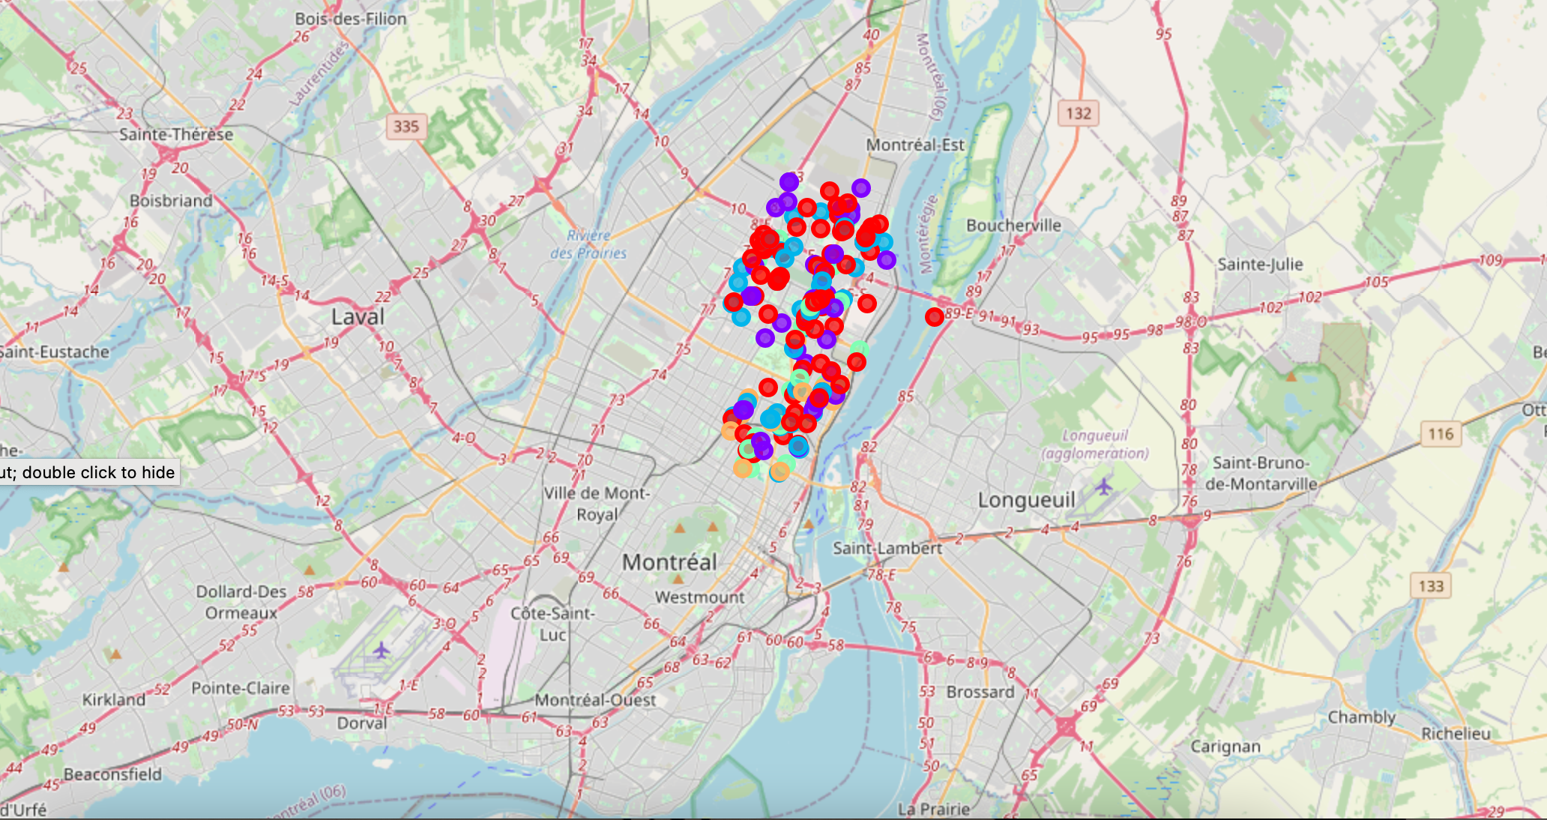

Image: Rivière-des-Prairies–Pointe-aux-Trembles Neighbourhood with the Foursquare API Likes results

The following is a histogram of the frequency of likes as compared to the number of food venues. This gives a quick visualization of the number of likes as compared to how many venues there are in the particular area, Rivière-des-Prairies–Pointe-aux-Trembles.

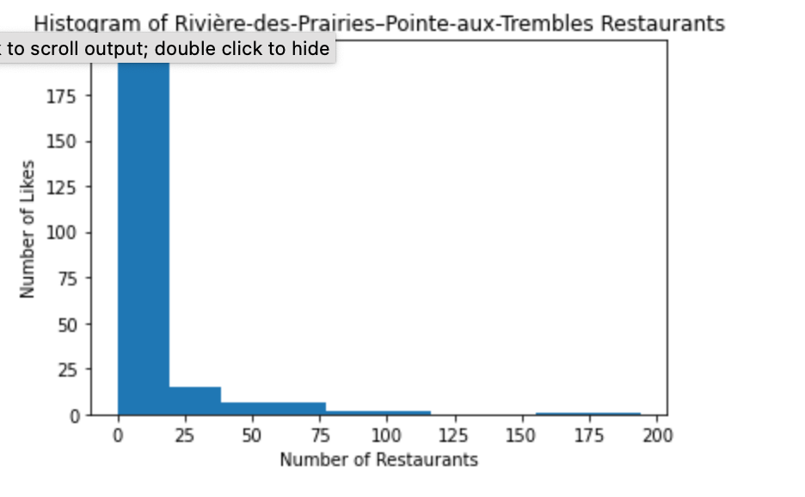

Image: Frequency Histogram

There are five clusters which show the venue separations for the rating categories “poor”, “acceptable”, “good”, “great” and “excellent”. They were set up according to percentiles to indicate the usual “5 star” ratings seen in most rating systems, using the 90th percentile to represent the “top ten percent”. The first five rows of the clusters can be seen as follows:

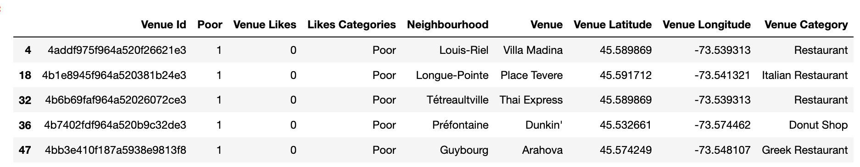

Image: The Poor Category Cluster, first five rows

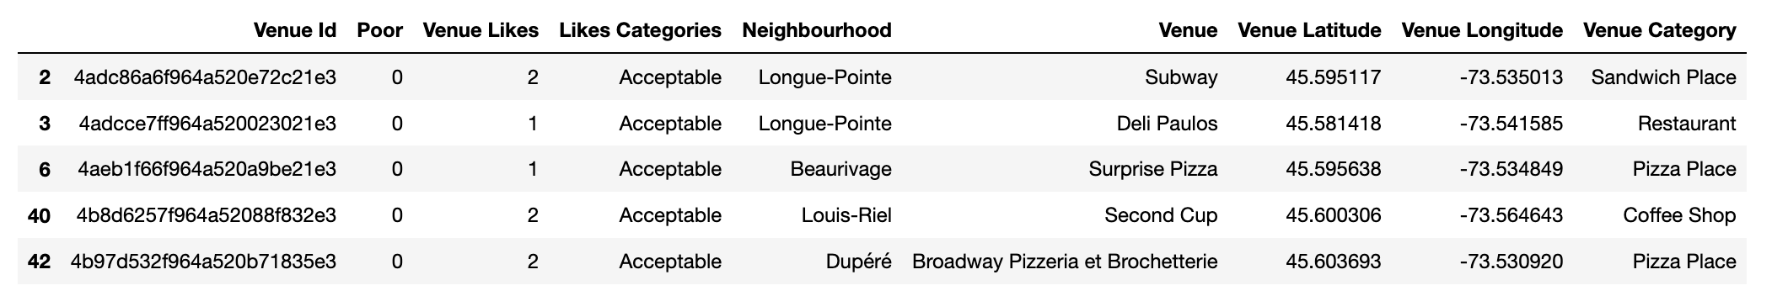

Image: The Acceptable Category Cluster, first five rows

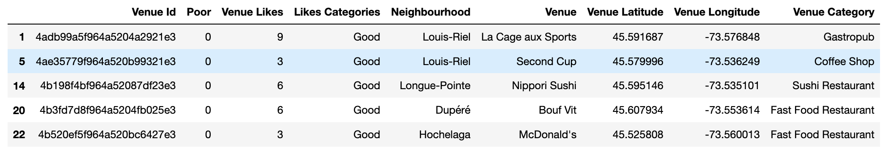

Image: The Good Category Cluster, first five rows

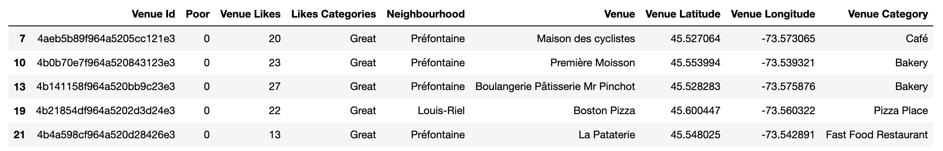

Image: The Great Category Cluster, first five rows

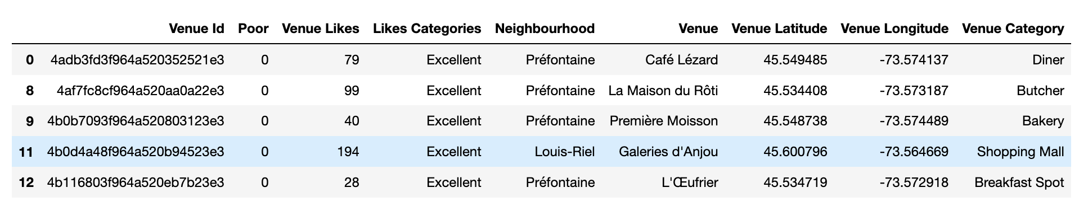

Image: The Excellent Category Cluster, first five rows

From these results, most food places with the largest number of likes are those in the neighbourhood of Préfontaine. There are a larger number of poorly rated restaurants which are dotted throughout the borough. Overall the rated venues seem to be spread evenly in the borough, with the “excellent” rating being the exception.

**Discussion**

There were some limitations to this study. They are as follows:

1. The data was too large to run every borough at once with the API restrictions, so for this study I used one borough and its neighbourhoods as a small sample for the entire city.
2. The study would only provide what information was available on FourSquare
3. The results would be different if the chosen location was a single neighbourhood and not a borough since they are based on location and the percentile of those venues in the location. Therefore, if the entirety of Montreal city was able to be run all at once in the API, the results would be based on the entire city and not a borough in the city.

**Conclusion**

This project was created by using FourSqaure for its data gathering for food-associated venues. More decisions can be made using the data gathered here. It can be used as is, to contribute toward the public’s decision making, or it can be used as a part of another project as another source of information.